Feature selction 8 features + Pipeline lg results

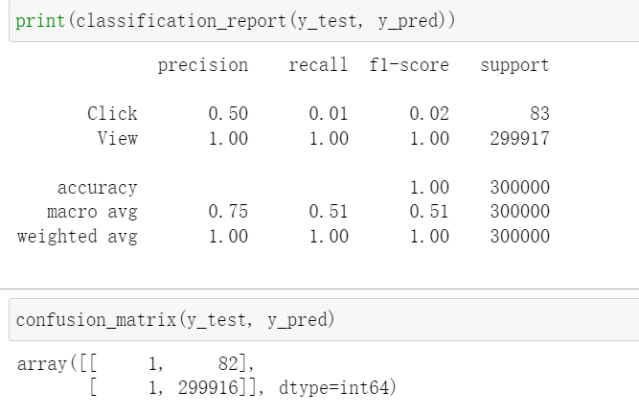

Feature selction 9 features + Pipeline DT results

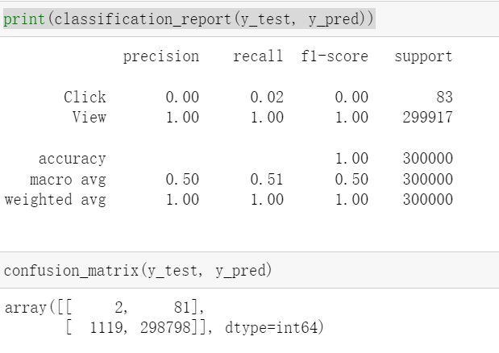

Feature selction 8 features + Pipeline lg results or

Feature selction 9 features + Pipeline lg results get the same results

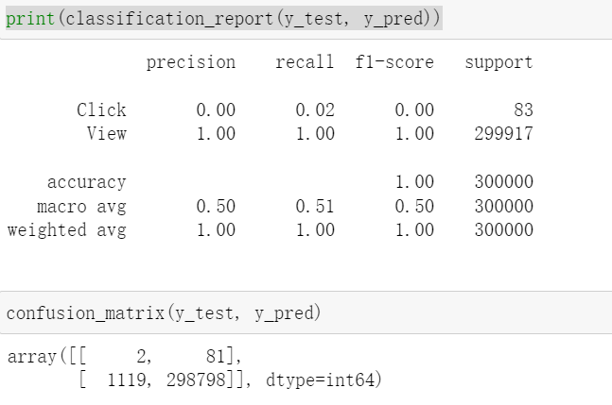

### **GOOD Model: Discion Tree Classifier with oversampling + feature selction 7 features ['Website', 'BannerSize', 'Brand', 'colour', 'InteractionTime', 'ActionMonth', 'DayofWeek']**

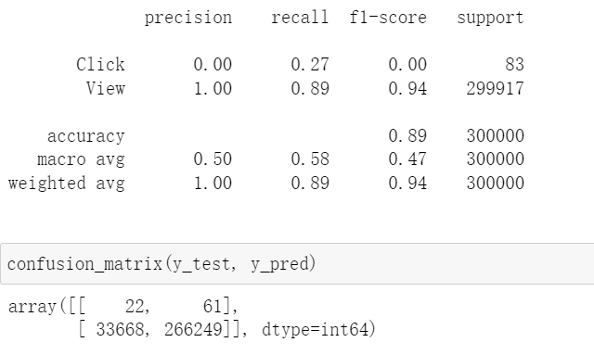

### **Final Model: LogisticRegression Classifier with oversampling + feature selction 7 features ['Website', 'BannerSize', 'Brand', 'colour', 'InteractionTime', 'ActionMonth', 'DayofWeek']**

BEST RESULTS WITH 68% PRECISION ON CLICK

